|  |
| --- |
| Experiment No. 3 |
| To realize half adder and full adder |
| Name: Rutuja Pednekar |
| Roll Number:47 |
| Date of Performance: |
| Date of Submission: |

Aim - To realize half adder and full adder.

Objective -

1) The objective of this experiment is to understand the function of Half-adder, Full-

adder, Half-subtractor and Full-subtractor.

2) Understand how to implement Adder and Subtractor using logic gates.

Components required -

1. IC’s - 7486(X-OR), 7432(OR), 7408(AND), 7404 (NOT)

2. Bread Board

3. Connecting wires.

Theory -

Half adder is a combinational logic circuit with two inputs and two outputs. The half

adder circuit is designed to add two single bit binary numbers A and B. It is the basic

building block for addition of two single bit numbers. This circuit has two outputs CARRY

and SUM.

Sum =A ⊕ B

Carry = A B

Full adder is a combinational logic circuit with three inputs and two outputs. Full

adder is developed to overcome the drawback of HALF ADDER circuit. It can add two one

bit umbers A and B. The full adder has three inputs A, B, and CARRY in,the circuit has two

outputs CARRY out and SUM.

Sum = (A⊕B) ⊕ Cin

Carry = AB + Cin (A⊕B)

Subtracting a single-bit binary value B from another A (i.e. A -B) produces a

difference bit D and a borrow out bit B-out. This operation is called half subtraction and the

circuit to realize it is called a half subtractor. The Boolean functions describing the half-

Subtractor are

Sum =A ⊕B

Carry = A’ B

Subtracting two single-bit binary values, B, Cin from a single-bit value A produces a

difference bit D and a borrow out Br bit. This is called full subtraction. The Boolean

functions describing the full-subtractor are

Difference = (A ⊕ B) ⊕Cin

Borrow = A’B + A’(Cin) + B(Cin)

Circuit Diagram and Truth Table -

Half-adder

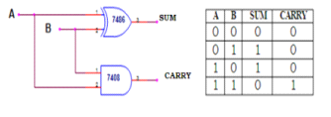

Full Adder

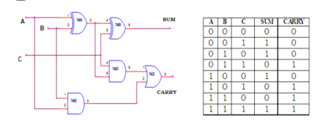

Procedure -

1. Verify the gates.

2. Make the connections as per the circuit diagram.

3. Switch on VCC and apply various combinations of input according to truth table.

4. Note down the output readings for half/full adder and half/full subtractor, Sum/difference

and the carry/borrow bit for different combinations of inputs verify their truth tables.

OUTPUT:

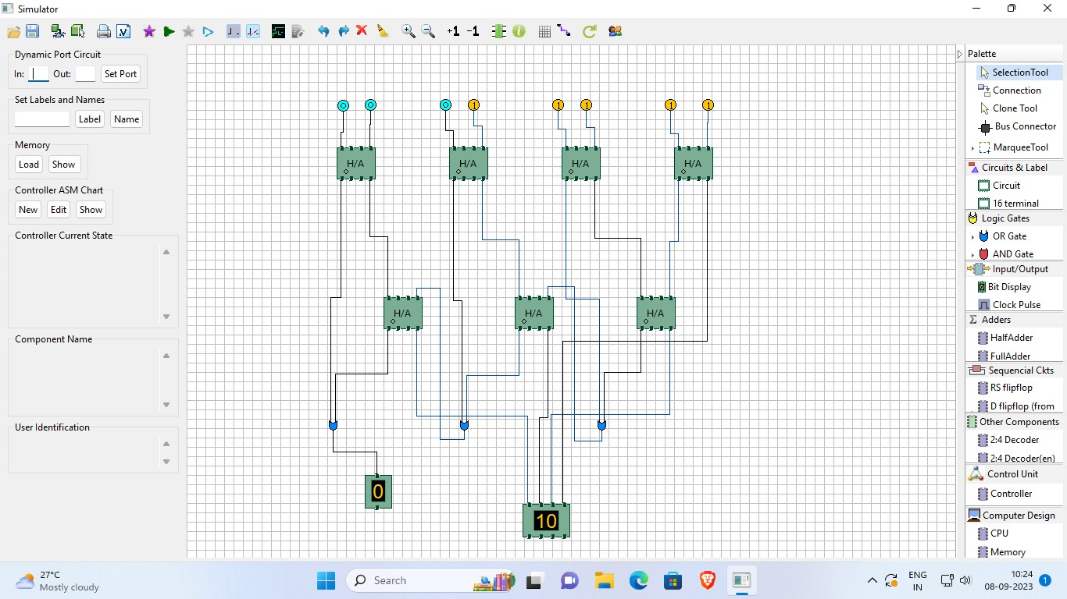

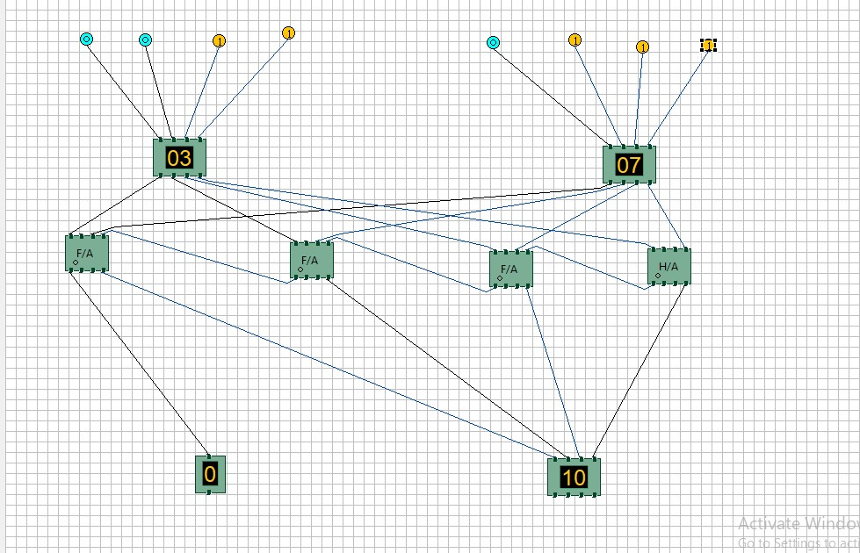

CONCLUSION:

Half adders provide the basic ability to add two binary digits, but lack carry-over capability. Full adders, however, include an extra input for carry-in, allowing them to add three binary digits and account for previous carries. Both are essential in digital computing, forming the basis for complex arithmetic operations and playing a crucial role in the development of modern technology. Mastery of these concepts is key for digital electronics engineers and computer scientists.